EA SLA Processing Shiny app
An app written in R and Shiny to process data files output from Recorder using the XML script supplied by the EA. The app replicates the functionality in the Commercial Restrictions Macro when the SLA and EA search options are selected. However, some functionality has not been included as the XML script does some processing that the macro used to do.
There are options:
- To specify the CSV file containing the data
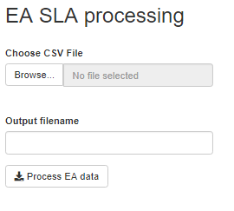

Output
- An Excel spreadsheet. Some fields may be highlighted if there is data that needs to be checked before the next stage of processing.

Running the app
The source files for the EA SLA are typically too big to host the Shiny app online. Therefore it needs to be run within RStudio. See the document “R Shiny and Github” for notes on how to do this

Code overview
The code makes extensive use of the ERIC_Data_Proc data processing library developed in R.
- Get input parameters
- Read the data from the input file
- Format the date fields
- Format the data and check for:
    - House numbers in location
    - Zero abundances
    - Swear words in comments
    - E-mail addresses in comments or recorder name
- Write it to an Excel spreadsheet highlighting any fields as necessary
- Save the Excel spreadsheet, asking the user for the name and location

Anne Donnelly – 25/07/22

